Practice Exercise 1

1) Create a table name STUDENT with following structure.

|  |  |  |  |  |
| --- | --- | --- | --- | --- |
|  | Column |  |  |  |
| # | Name | Description | Data Type |  |
|  |  |  |
|  |  | Registration |  |  |
| 1 | RegNo | Number | NUMBER(3) |  |
| 2 | Name | Student Name | VARCHAR(15) |  |
|  |  | Gender of the |  |  |
| 3 | Gender | student | CHAR(1) |  |
| 4 | DOB | Date of Birth | DATE |  |
| 5 | MobileNo | Mobile Number | NUMBER(10) |  |
| 6 | City | Location of stay | VARCHAR(15) |  |

Ans:

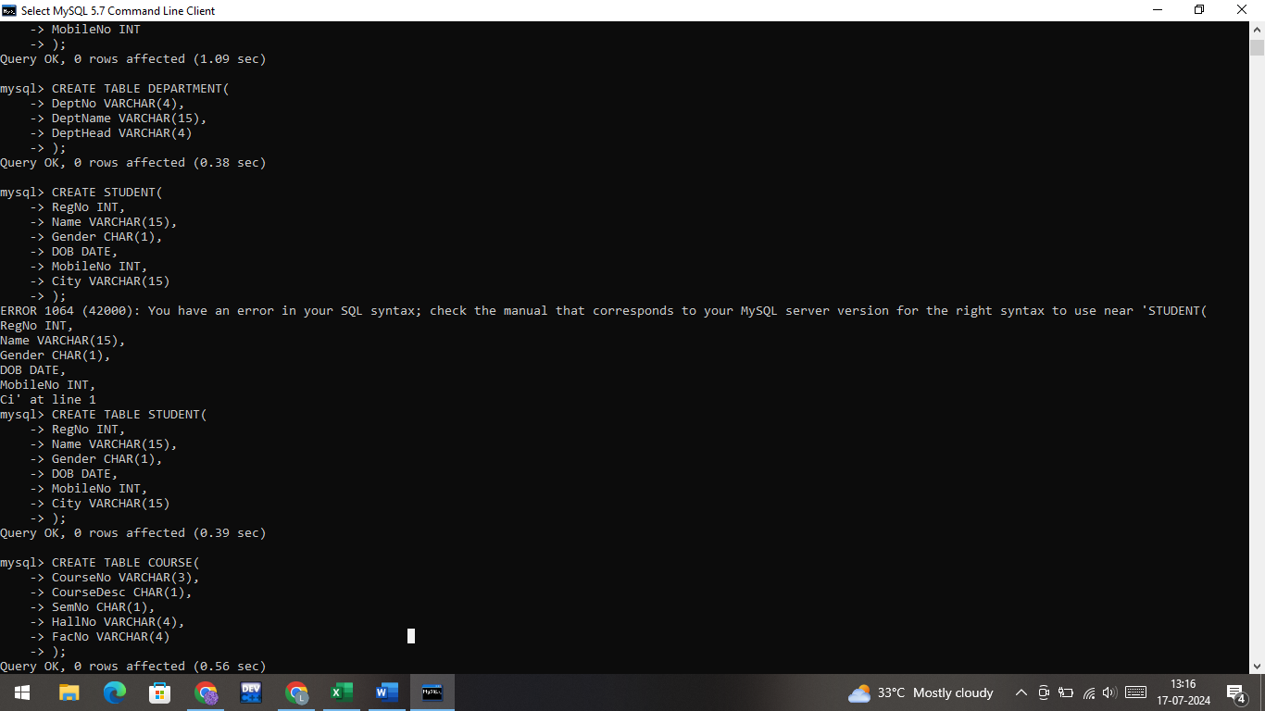

2) Create a table name FACULTY with following structure.

|  |  |  |  |  |
| --- | --- | --- | --- | --- |
|  | Column |  |  |  |
| # | Name | Description | Data Type |  |
|  |  |  |
| 1 | FacNo | Faculty Identifier | VARCHAR(4) |  |
| 2 | FacName | Faculty Name | VARCHAR(15) |  |
| 3 | Gender | Gender of faculty | CHAR(1) |  |
| 4 | DOB | Date of Birth | DATE |  |
| 5 | DOJ | Date of Join | DATE |  |
| 6 | MobileNo | Mobile Number | NUMBER(10) |  |

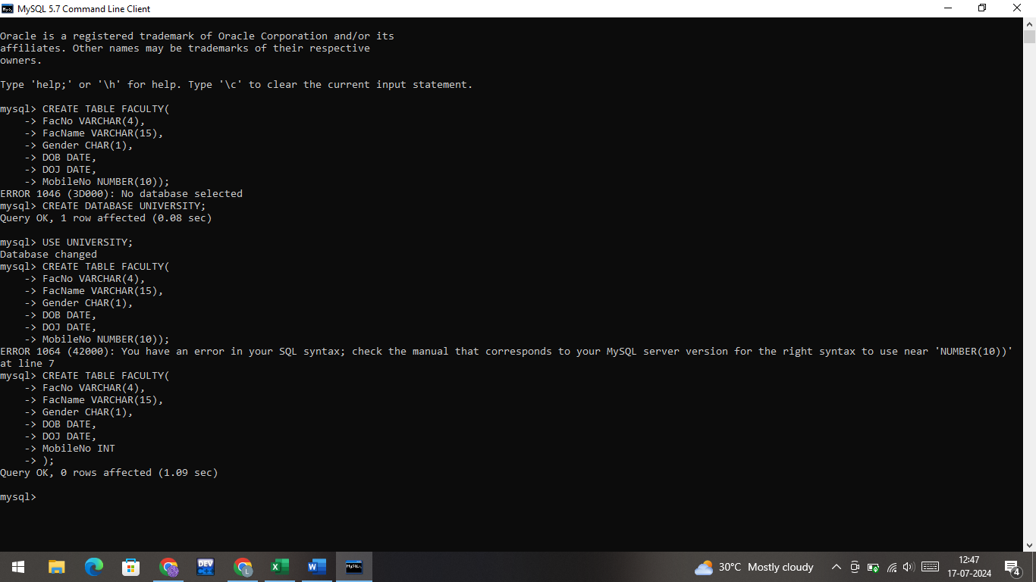

3) Create a table name DEPARTMENT with following structure.

|  |  |  |  |  |
| --- | --- | --- | --- | --- |
|  | Column |  |  |  |
| # | Name | Description | Data Type |  |
|  |  |  |
| 1 | DeptNo | Department Identifier | VARCHAR(4) |  |
| 2 | DeptName | Department Name | VARCHAR(15) |  |
| 3 | DeptHead | Department Head | VARCHAR(4) |  |

Ans:

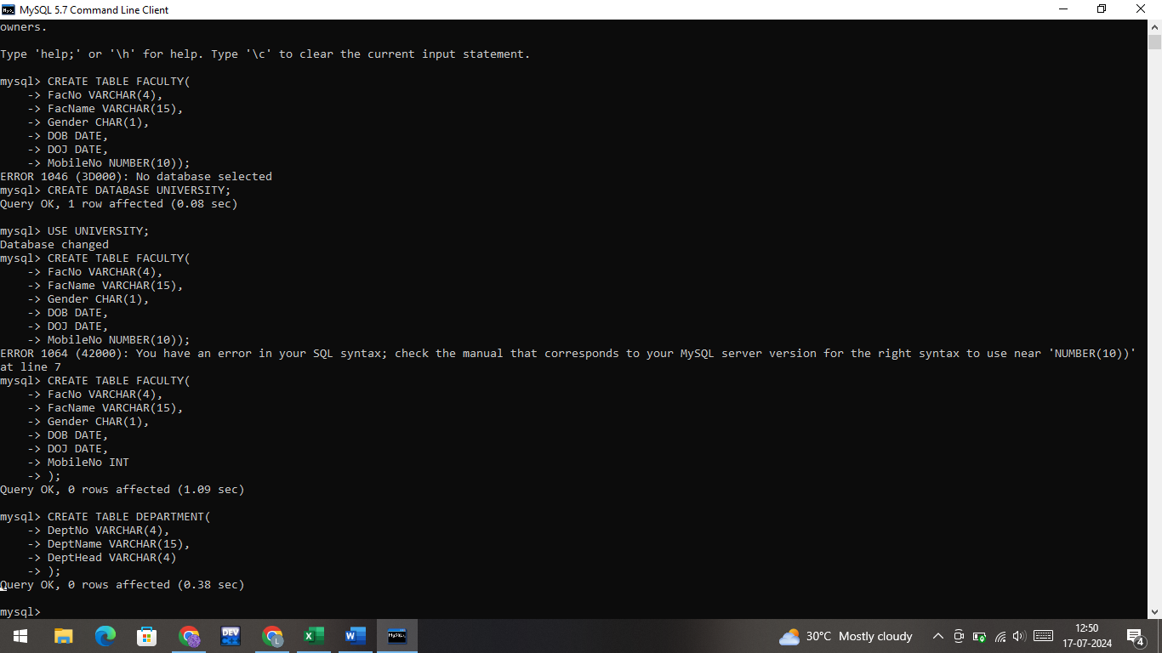

4) Create a table name COURSE with following structure.

|  |  |  |  |  |
| --- | --- | --- | --- | --- |
|  | Column |  |  |  |
| # | Name | Description | Data Type |  |
|  |  |  |
| 1 | CourseNo | Course Identifier | VARCHAR(3) |  |
|  |  | Course |  |  |
| 2 | CourseDesc | Description | VARCHAR(14) |  |
| 3 | CourseType | Course Type | CHAR(1) |  |
| 4 | SemNo | Semester Number | CHAR(1) |  |
| 5 | HallNo | Hall Number | VARCHAR(4) |  |
| 6 | FacNo | Faculty Identifier | VARCHAR(4) |  |

Ans:

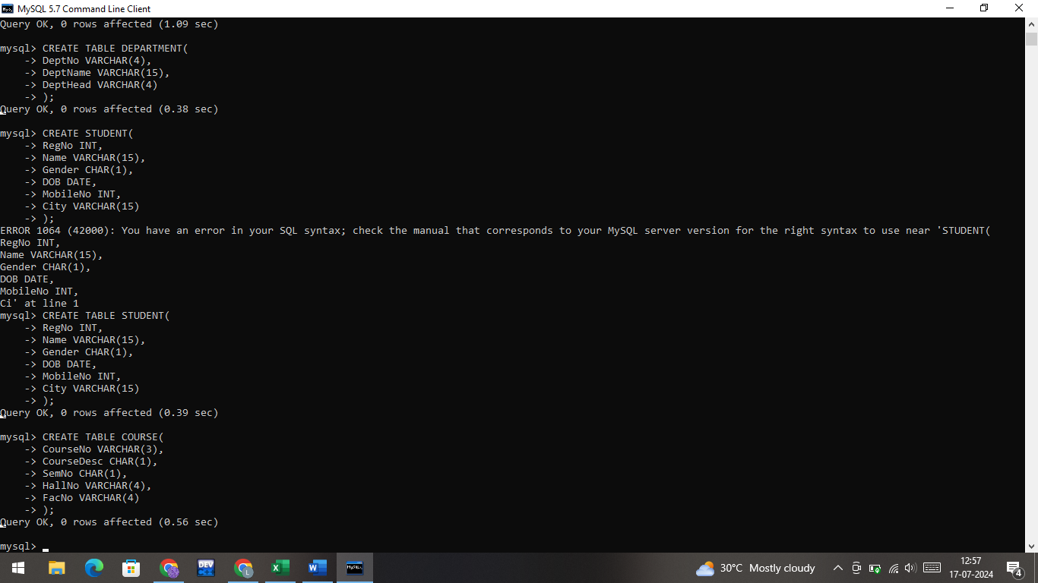

1. Modify the table FACULTY by adding a column name DeptNo of datatype VARCHAR(4)

Ans:



6) Alter the table STUDENT with following structure.

|  |  |  |
| --- | --- | --- |
|  | Column | Constraints |
| # | Name |  |
|  |  | PRIMARY |
| 1 | RegNo | KEY |
| 2 | MobileNo | NOT NULL |

1. Alter the table name FACULTY with following structure. The DeptNo in this table refers the DeptNo in the DEPARTMENT table.

|  |  |  |  |  |  |  |  |  |  |
| --- | --- | --- | --- | --- | --- | --- | --- | --- | --- |
|  |  |  | Column | | Constraints |  |  |  |  |
|  | # |  | Name | |  |  |  |  |  |
|  |  |  | FacNo | | PRIMARY |  |  |  |  |
|  | 1 |  | KEY |  |  |  |  |
|  |  |  |  |  |  |  |  |
|  |  |  | Gender | | CHECK |  |  |  |  |
|  | 2 |  | ‘M’ or ‘F’ |  |  |  |  |
|  |  |  |  |  |  |  |  |
|  | 8) | After the FACULTY table is successfully created, test if you can add a constraint | | | | | | |  |
|  | FOREIGN KEY to the DeptNo of this table. | | | | | | | |  |
|  | 9) | Alter the table name DEPARTMENT with following structure. | | | | | | |  |
|  |  |  |  |  |  | |  |  |  |
|  |  |  | Column |  | Constraint | |  |  |  |
|  | # |  | Name |  |  |  |  |  |  |
|  |  |  | DeptNo |  | PRIMARY | |  |  |  |
|  | 1 |  |  | KEY | |  |  |  |
|  |  |  |  |  |  |  |
|  |  | 10) Alter the table name COURSE with following structure. | | | | | | |  |
|  |  |  |  | |  | | |  |  |
|  |  |  | Column |  | Constraint | | |  |  |
|  | # |  | Name |  |  |  |  |  |  |
|  |  |  | CourseNo |  | PRIMARY | | |  |  |
|  | 1 |  |  | KEY | | |  |  |
|  |  |  |  |  |  |
|  | 2 |  | SemNo |  | 1 to 6 | | |  |  |

Answers of 7 to 10:

7.

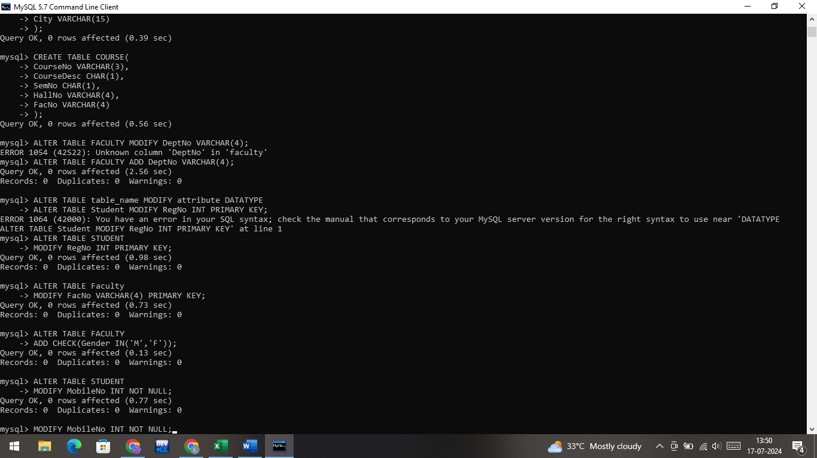

8.

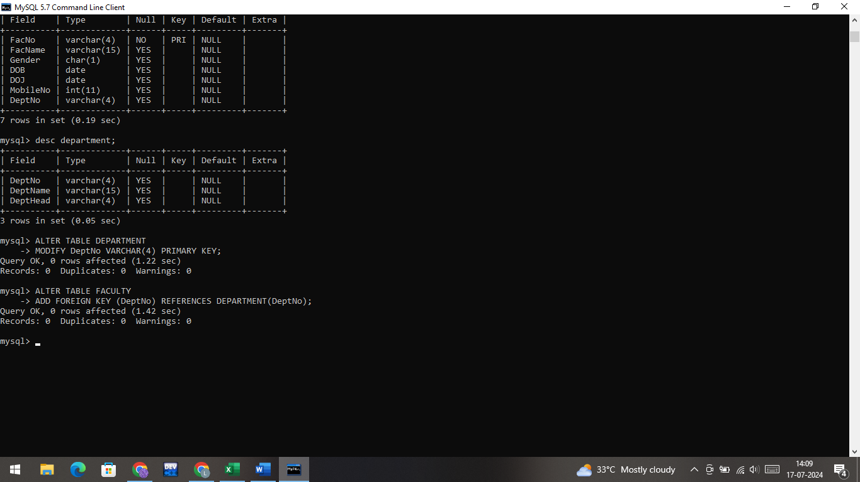

9.

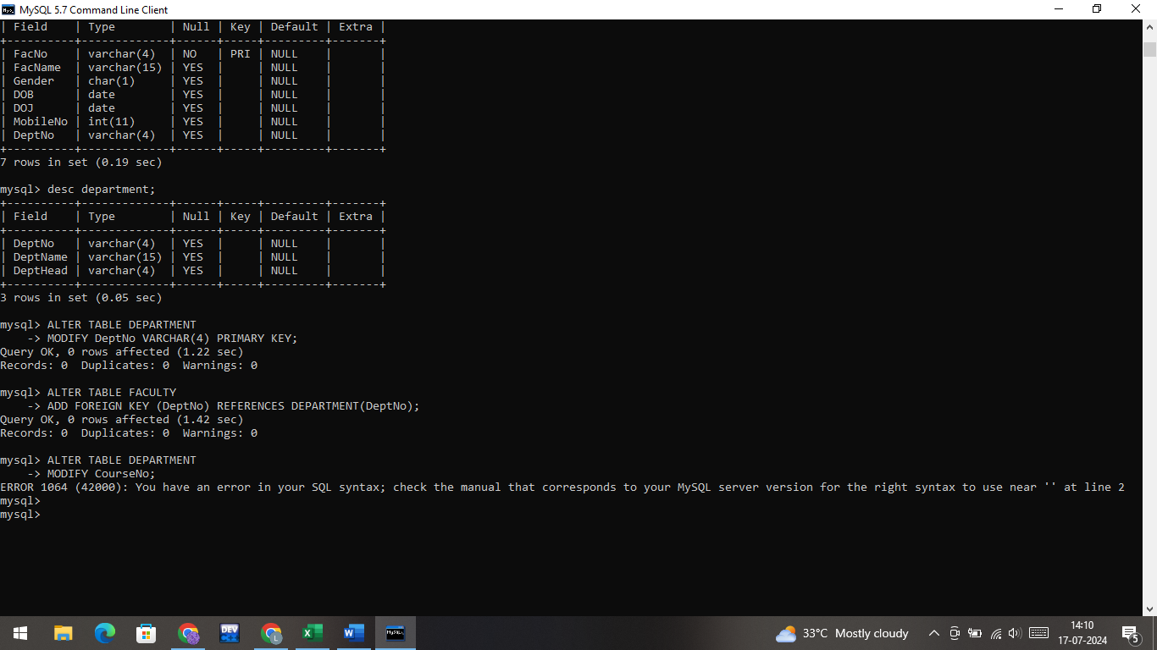

10.

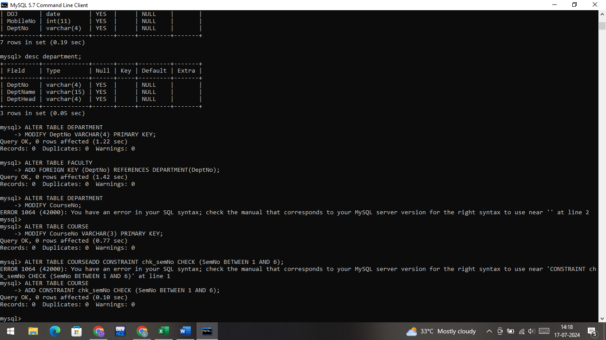

**Practice Questions**:

1. Populate all the five tables with your own data.

Ans:

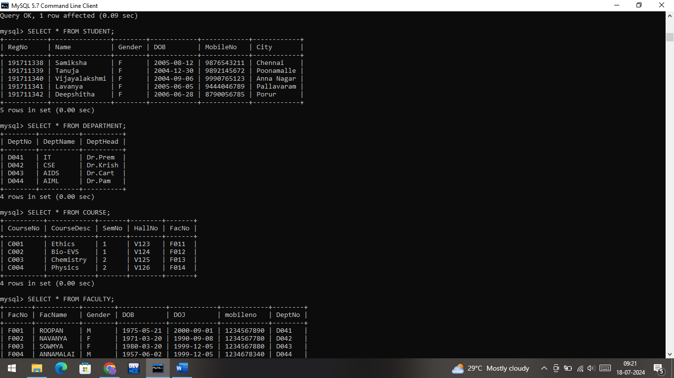

1. Update the value of student name whose register number is ‘191711342’

Ans:

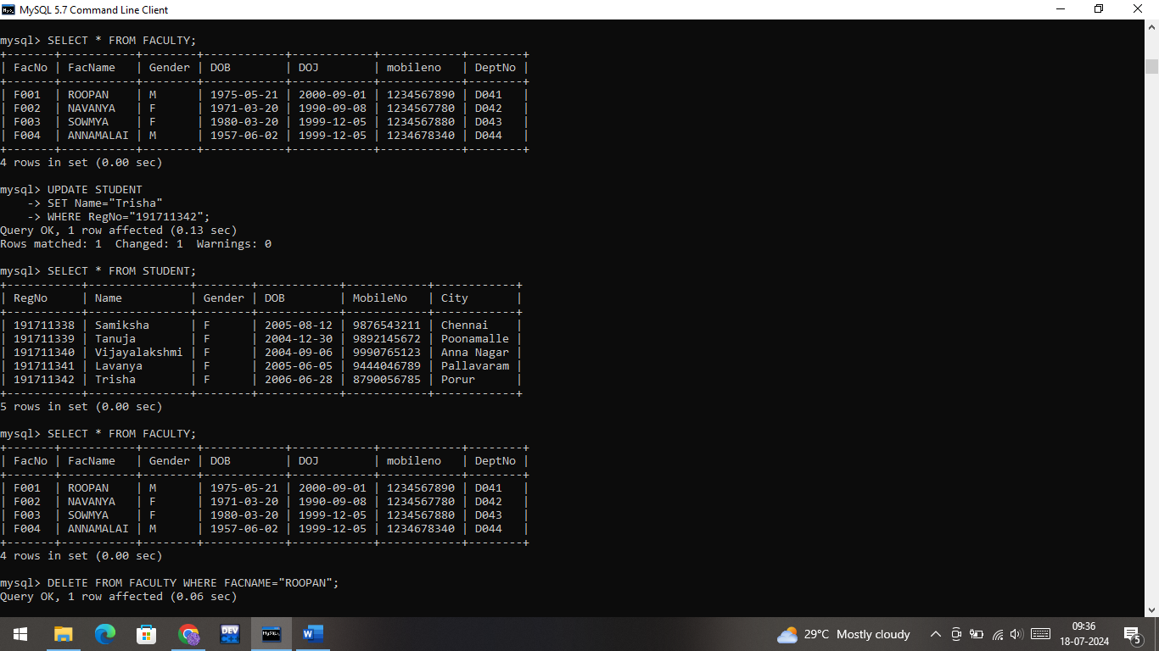

1. Delete the record in the table FACULTY, who resigned her job.

Ans:

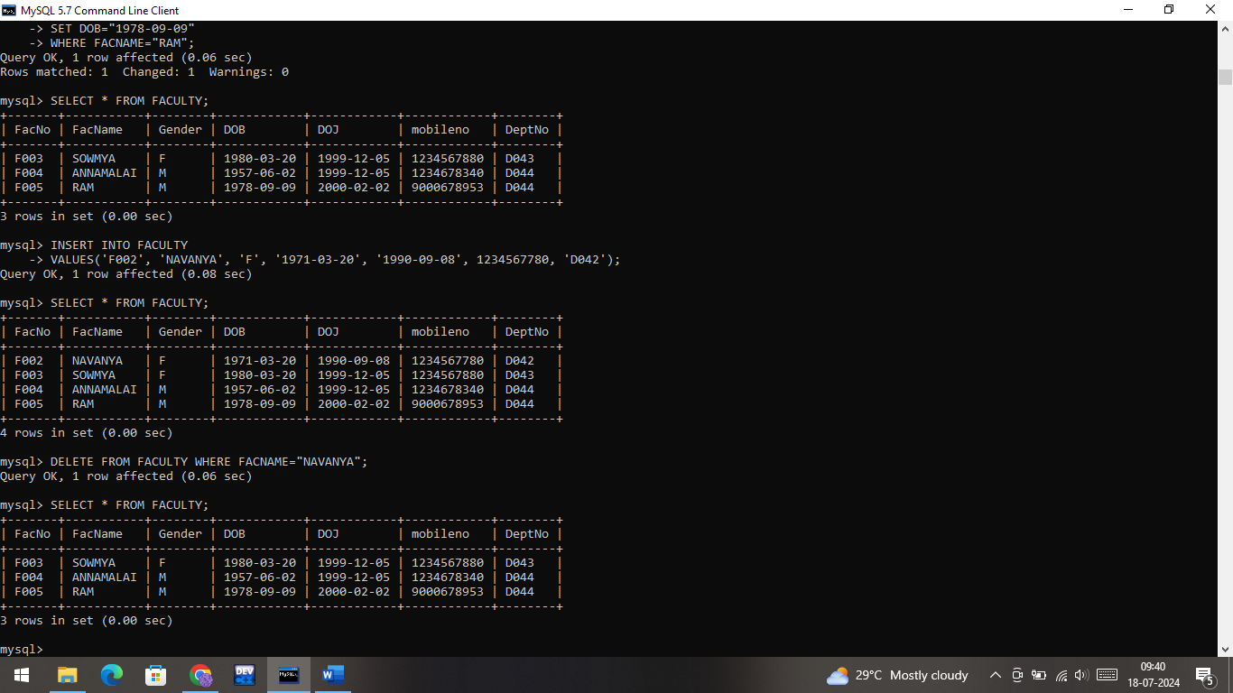

1. Modify the date of birth for the faculty whose name is 'RAM' with a value ‘1983-05-01’.

Ans:

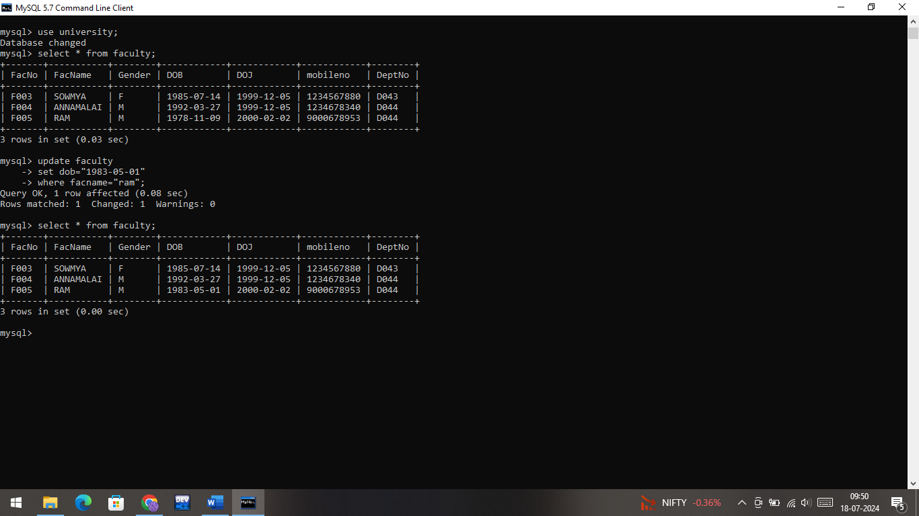

1. Remove all faculty who are having over 65 years

Ans:

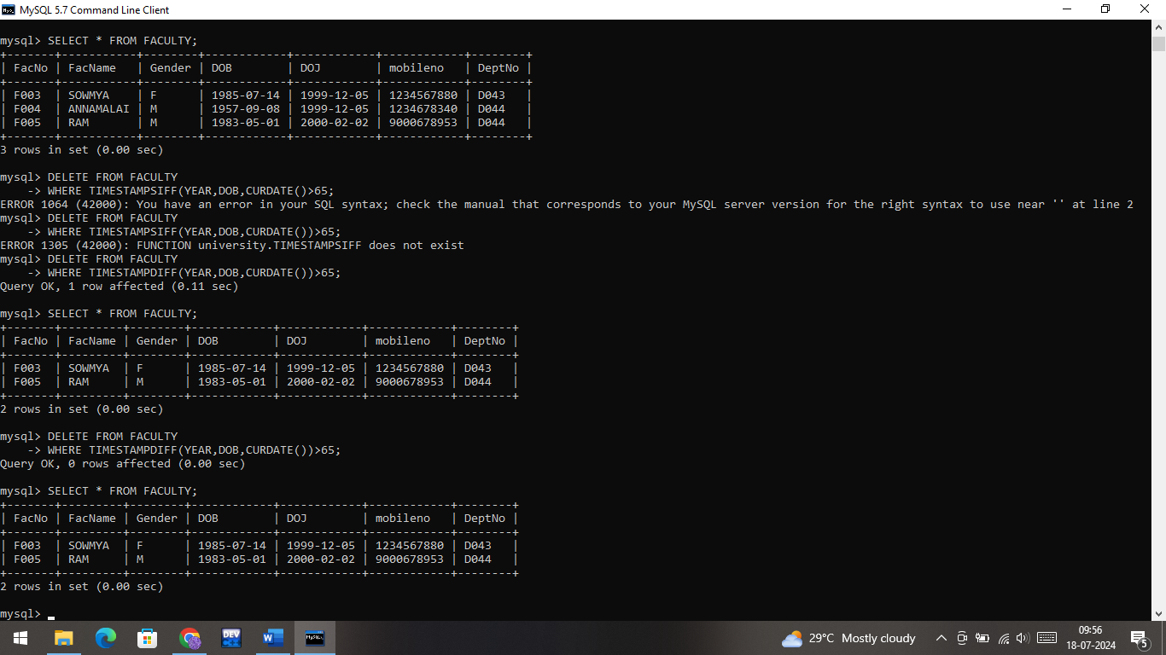

1. View all the records from the five tables.

Ans:

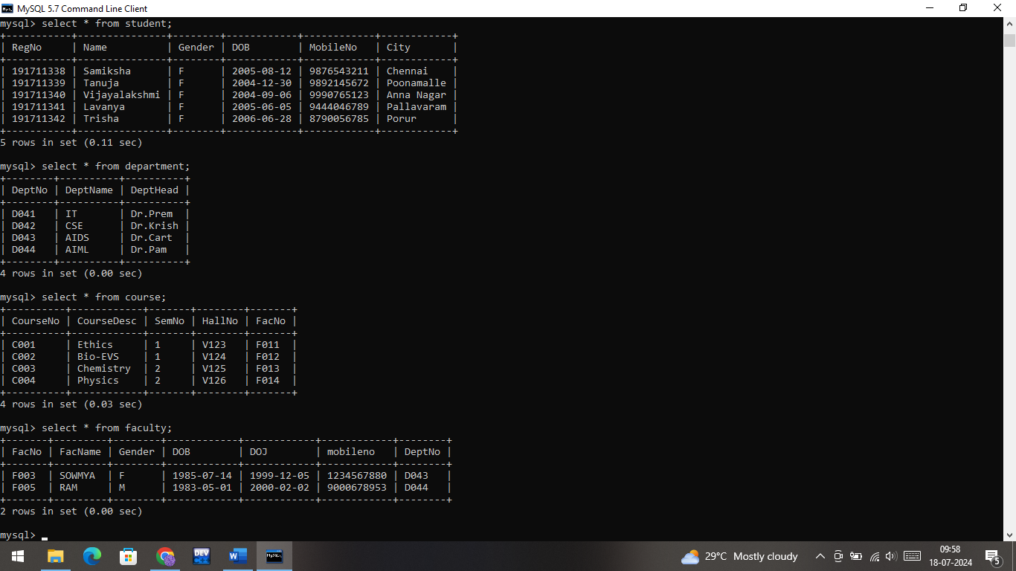

**WHERE Clause Questions::**

1. The student counsellor wanted to display the registration number, student name and date of birth for all the students.

Ans:

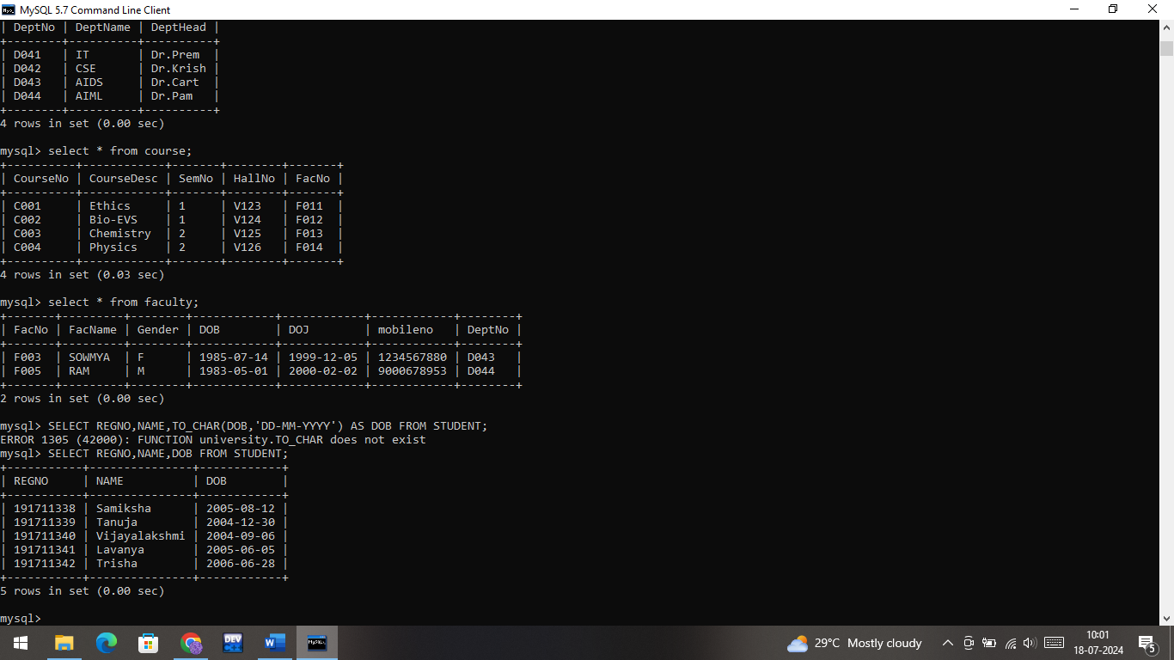

1. The controller of examinations wanted to list all the female students

Ans:

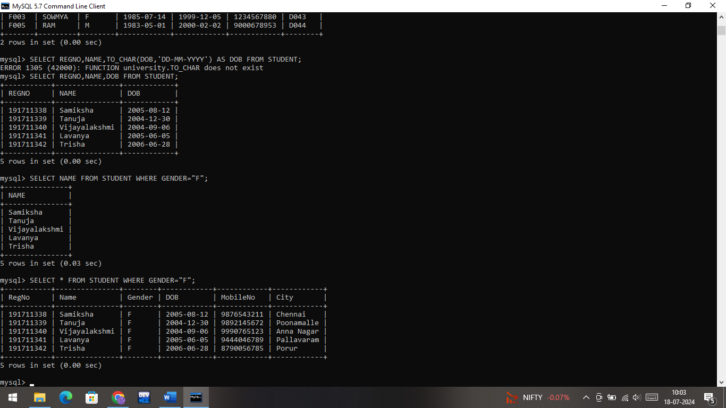

1. Who are the boy students registered for course with the course number “C001“

Ans:

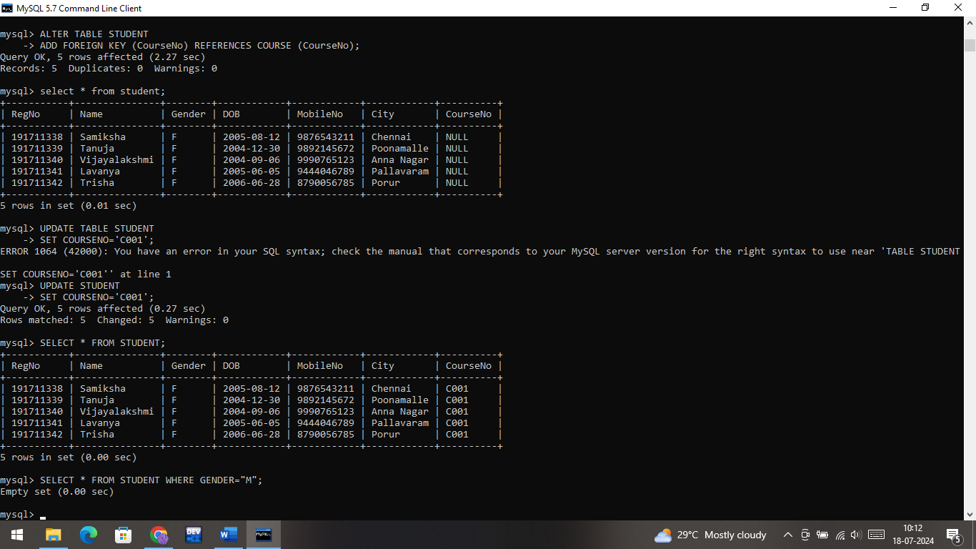

1. Display all faculty details joined before “November 2014”

Ans:

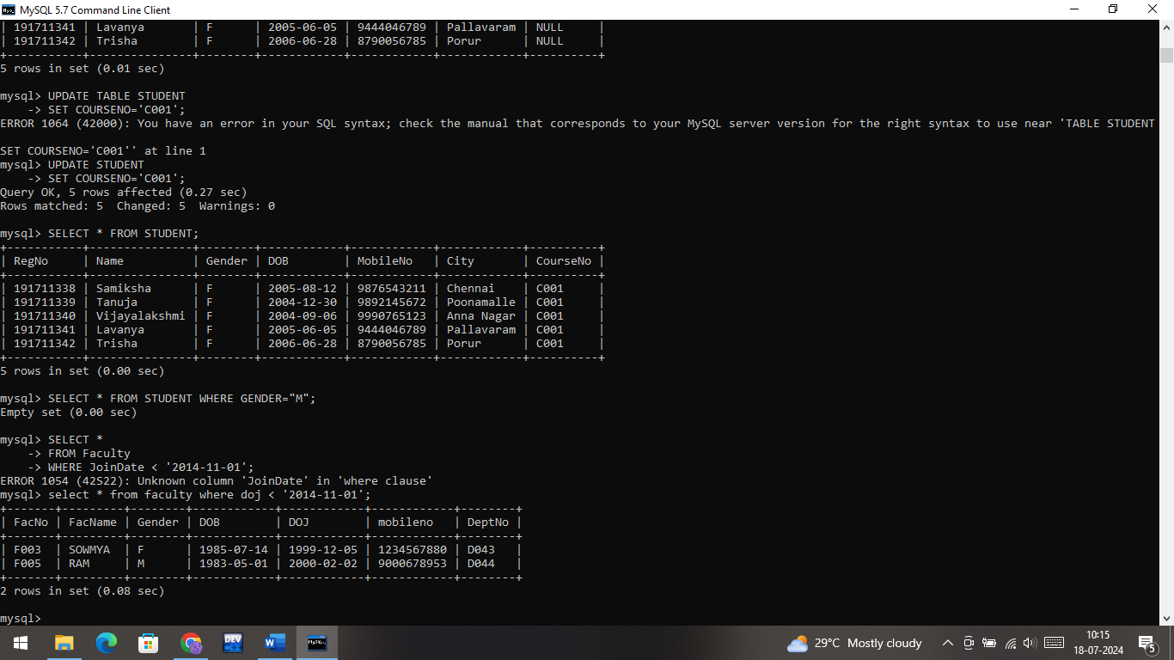

1. Display all the courses not allotted to halls

Ans:

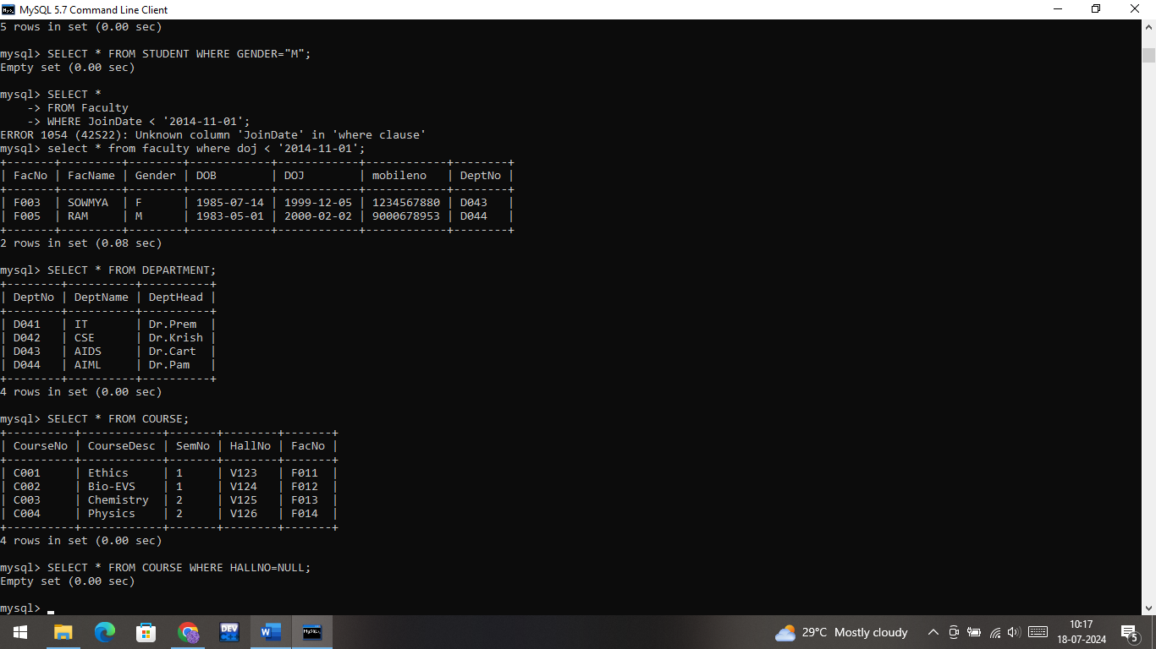



**LIKE Clause Questions::**

1. List the students whose name ends with the substring “ma”

Ans:

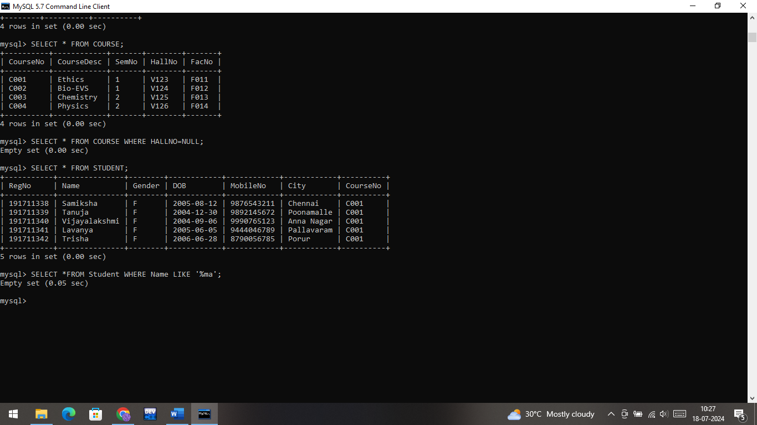

1. Display all students whose name contains the substring “ma”

Ans:

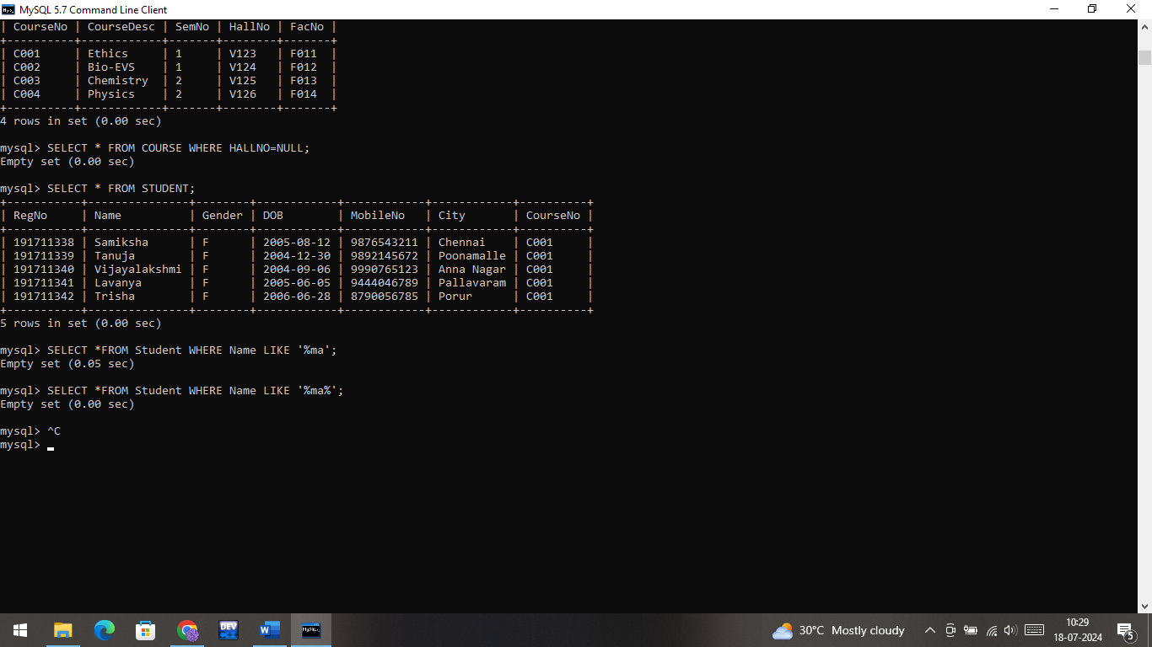

1. Find all the students who are located in cities having “Sal” as substring

Ans:

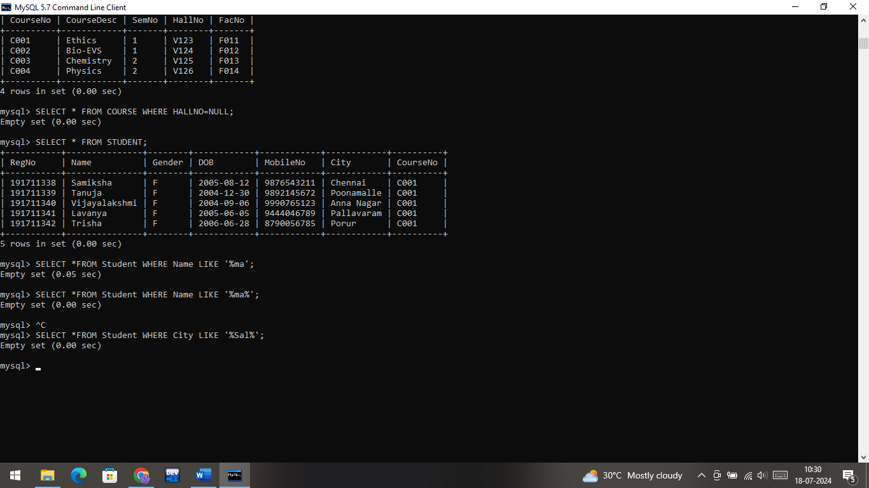

1. Display the students whose names do not contain six letters.

Ans:

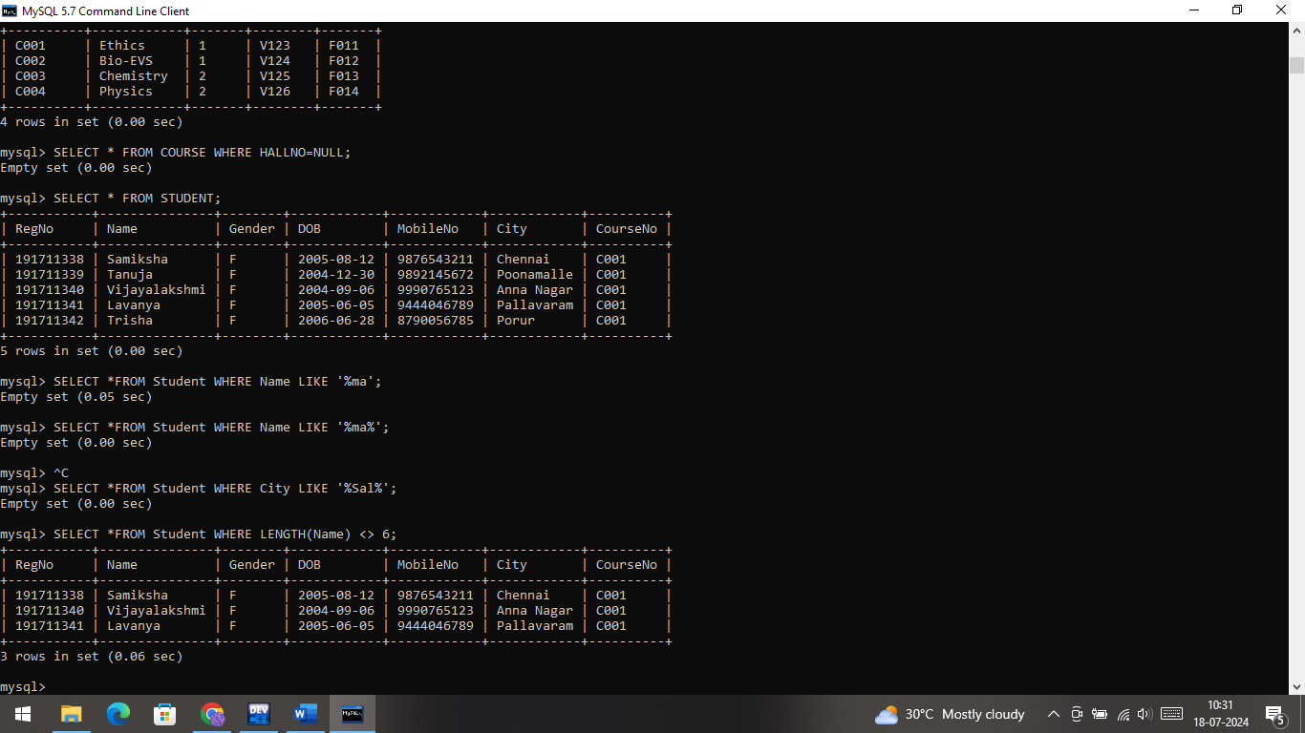

1. Find all the students whose names contains “th”

Ans:

